Docker challenge -02
The goal of this exercise is to test your understanding of a Cloud Compute deployment with Terraform.
You are tasked with creating a codebase for a microservice deployment on a cloud environment, using Terraform. Since our focus is not the application itself, the service will be a simple web server that returns a static page.
Requirements
Service Details
The service will be a simple web server that returns a static page.
You can use apache2 or nginx to serve a simple HTML file.
The service should be containerized and stored in a Docker registry.
The service should be deployed on a single VM instance as a docker container.
The image should be pulled from the registry specified earlier.
The service should not be accessible from the internet but only through a Load Balancer, except for SSH access from specific IP addresses.
Deliverables
You are to provide the following as part of your solution:
Dockerfile to build the image.
Terraform codebase to deploy the following:
Docker registry
VPC and all required networking resources
EC2 instance
Load Balancer
Notes
Since a CI/CD pipeline is not part of this exercise, we will work around that with the help of Terraform.
To push the image to the Docker registry, build the image locally before running the Terraform code.
Once the image registry is created, use Terraform to push the local image to the registry.
Similarly, use Terraform to pull the image from the registry and run it on the VM instance once it is created.
For SSH access:
Use a locally created key.
Add it to the cloud provider key storage.
Attach it to the instance.
Use Terraform best practices for file structure and code organization.
Use variables, locals, modules, etc. when appropriate.
Include all tfvars, scripts, and other helper files used to deploy the application.
You may use any cloud provider of your choosing, although AWS is preferred.
Use a free tier account or a trial account to deploy the resources.
Clear steps by step:
Part 1 – What you need before Terraform
1. Install required tools (on your laptop)
You must have:
# AWS CLI
# Terraform
sudo yum install -y yum-utils shadow-utils
sudo yum-config-manager --add-repo https://rpm.releases.hashicorp.com/AmazonLinux/hashicorp.repo
sudo yum install terraform
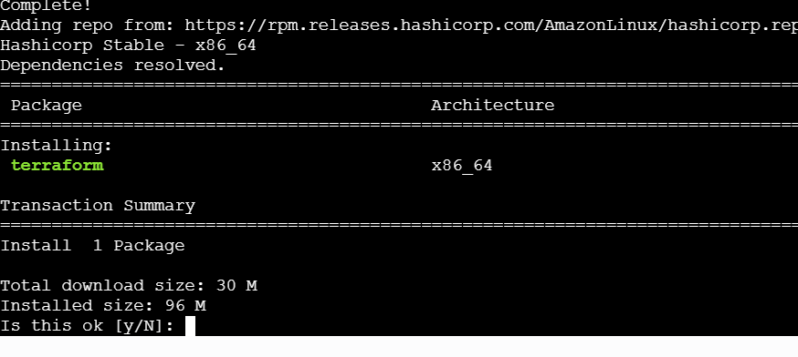
#Docker
You can check:
aws –version

2. Configure AWS credentials
Login using AWS CLI:
aws configure
Provide:
AWS Access Key ID
AWS Secret Access Key
Region (example: us-east-1)
Output format (json)
*I have already configured soican see this output list out the s3 bucket
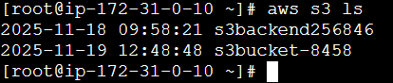

Create SSH key (for EC2 login)
On Linux / Mac / WSL:
ssh-keygen -t rsa -b 4096 -f ~/.ssh/microservice-key
This will create:
Private key: ~/.ssh/microservice-key
Public key: ~/.ssh/microservice-key.pub
We’ll use the public key path in Terraform.
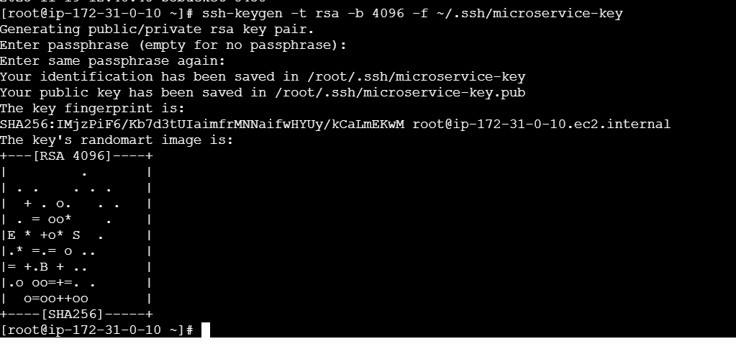

4. Get your public IP (for SSH access)
Search in Google: “what is my IP”
Suppose it is: 49.37.xx.yy → in Terraform we will use: 49.37.xx.yy/32
This ensures only you can SSH into the EC2.

# Now ceate Dockerfile # Vi Dockerfile
FROM nginx:alpine
RUN rm -rf /usr/share/nginx/html/*
COPY index.html /usr/share/nginx/html/index.html
EXPOSE 80
CMD ["nginx", "-g", "daemon off;"]

# create index.html file
<!DOCTYPE html>
<html lang="en">
<head>
<meta charset="UTF-8">
<title>Welcome</title>
<style>
body {
font-family: Arial, sans-serif;
background-color: #f2f2f2;
text-align: center;
padding-top: 100px;
}
h1 {
color: #2c3e50;
}
</style>
</head>
<body>
<h1>Hello, World! 👋</h1>
<p>This is a sample index.html file.</p>
<p>Deployed using Docker & Jenkins 🚀</p>
</body>
</html>
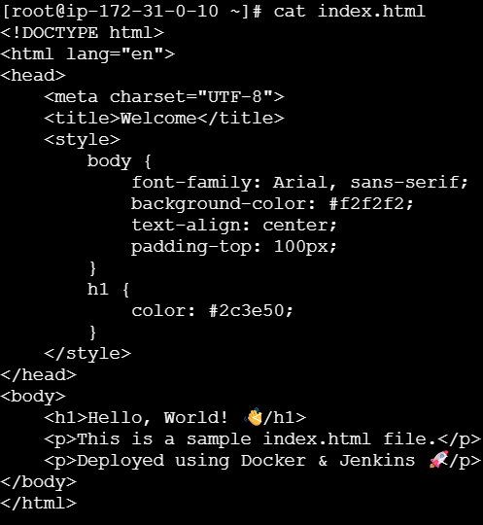
#Now create the main.tf for terraform
# vi main.tf
#################################
# Terraform & Provider
#################################
terraform {
required_version = ">= 1.5.0"

required_providers {
aws = {
source = "hashicorp/aws"
version = "~> 5.0"
}
}
}

provider "aws" {
region = var.aws_region
profile = var.aws_profile == "" ? null : var.aws_profile
}

#################################
# Variables (INLINE – no variables.tf)
#################################

variable "aws_region" {
type = string
default = "us-east-1"
}

variable "aws_profile" {
type = string
default = ""
}

variable "allowed_ssh_cidr" {
description = "CIDR allowed to SSH"
type = string
default = "0.0.0.0/0"
}

#################################
# Networking
#################################

data "aws_availability_zones" "available" {}

resource "aws_vpc" "main" {
cidr_block = "10.0.0.0/16"
enable_dns_support = true
enable_dns_hostnames = true
}

resource "aws_internet_gateway" "igw" {
vpc_id = aws_vpc.main.id
}

resource "aws_subnet" "public" {
vpc_id = aws_vpc.main.id
cidr_block = "10.0.1.0/24"
availability_zone = data.aws_availability_zones.available.names[0]
map_public_ip_on_launch = true
}

resource "aws_route_table" "public" {
vpc_id = aws_vpc.main.id

route {
cidr_block = "0.0.0.0/0"
gateway_id = aws_internet_gateway.igw.id
}
}

resource "aws_route_table_association" "public_assoc" {
subnet_id = aws_subnet.public.id
route_table_id = aws_route_table.public.id
}

#################################
# ECR Repository
#################################

resource "aws_ecr_repository" "service" {
name = "microservice-demo-repo"
force_delete = true
}

locals {
ecr_repo_url = aws_ecr_repository.service.repository_url
}

#################################
# Push Docker Image to ECR (local machine)
#################################

resource "null_resource" "push_image" {
provisioner "local-exec" {
command = <<EOF
aws ecr get-login-password --region ${var.aws_region} \
| docker login --username AWS --password-stdin ${local.ecr_repo_url}

docker build -t microservice:latest .
docker tag microservice:latest ${local.ecr_repo_url}:latest
docker push ${local.ecr_repo_url}:latest
EOF
}

depends_on = [aws_ecr_repository.service]
}

#################################
# SSH Key Pair
#################################

resource "aws_key_pair" "ssh_key" {
key_name = "microservice-key"
public_key = file("${path.module}/microservice-key.pub")
}

#################################
# Security Group
#################################

resource "aws_security_group" "instance_sg" {
name = "instance-sg"
vpc_id = aws_vpc.main.id

ingress {
from_port = 22
to_port = 22
protocol = "tcp"
cidr_blocks = [var.allowed_ssh_cidr]
}

ingress {
from_port = 80
to_port = 80
protocol = "tcp"
cidr_blocks = ["0.0.0.0/0"]
}

egress {
from_port = 0
to_port = 0
protocol = "-1"
cidr_blocks = ["0.0.0.0/0"]
}
}

#################################
# EC2 Instance (x86 SAFE)
#################################

data "aws_ami" "amazon_linux" {
most_recent = true
owners = ["amazon"]

filter {
name = "name"
values = ["al2023-ami-*-x86_64"]
}
}

resource "aws_instance" "web" {
ami = data.aws_ami.amazon_linux.id
instance_type = "t3.micro"

subnet_id = aws_subnet.public.id
key_name = aws_key_pair.ssh_key.key_name
vpc_security_group_ids = [aws_security_group.instance_sg.id]

associate_public_ip_address = true

user_data = <<EOF
#!/bin/bash
dnf update -y

dnf install -y docker awscli
systemctl start docker
systemctl enable docker

aws ecr get-login-password --region ${var.aws_region} \
| docker login --username AWS --password-stdin ${local.ecr_repo_url}

docker pull ${local.ecr_repo_url}:latest
docker run -d -p 80:80 --restart always --name web ${local.ecr_repo_url}:latest
EOF

depends_on = [null_resource.push_image]

tags = {
Name = "microservice-web"
}
}

#################################
# Outputs
#################################

output "instance_public_ip" {
value = aws_instance.web.public_ip
}

output "ecr_repository_url" {
value = aws_ecr_repository.service.repository_url
}

Tips copy the key to the terraform project file
#cp /root/.ssh/microservice-key.pub ./microservice-key.pub
Mow run the terraform code
#terraform init
#terraform plan
#terraform apply

